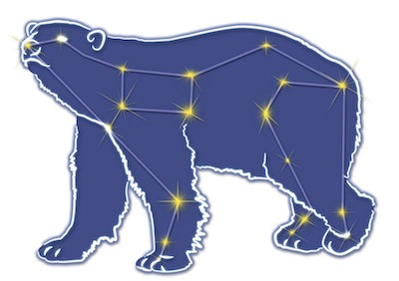
Great Bear Petroleum Operating LLC
A New Direction for the Last Frontier
601 W. 5th Ave., Suite 505, Anchorage, AK 99501
Phone: (907) 868-8070, Fax: (907) 868-3887

August 3, 2011

Ms. Cathy Foerster, Chair
Alaska Oil and Gas Conservation Commission
601 West 5th Ave., Suite 505
Anchorage, Alaska 99501

RE: Weekly Report of Operations
Great Bear Petroleum: Alcor #1 (PTD # 212-057)

Dear: Ms. Foerster,
This is a report of Great Bear Petroleum’s well operations on the Alcor #1 for the period July 27 through August 2, 2012, inclusive.

July 27, 2012 10,085’ MW 10.6 ppg Vis 55 sec Incl 2.50˚
RIH from 649’ to 9,693’, tag fill. Wash to 10,006’. Displace 11.2 ppg trip mud with 10.6 ppg drilling mud. Wash to 10,015’. Cut core from 10,015’ to 10,085’.

July 28, 2012 10,103’ MW 11.2 ppg Vis 55 sec Incl 2.50˚
Core from 10,085’ to 10,103’. Displace well from 10.6 ppg drilling mud to 11.2 ppg tripping mud. POH and L/D core barrel.

July 29, 2012 10,103’ MW 11.2 ppg Vis 55 sec Incl 2.50˚
Finish L/D coring assy – no recovery. Perform weekly BOP test, witnessed by AOGCC’s Jeff Jones. M/U drilling BHA and RIH to 4,200’.

July 30, 2012 10,200’ MW 11.2 ppg Vis 64 sec Incl 2.23˚
RIH 4,200’ to 8,300’. MAD pass with LWD logs 8,300’ to 10,103’. Change out mud from 11.2 ppg tripping mud to 10.6 ppg drilling mud. Drill 10,103’ to 10,200’.

July 31, 2012 10,573’ MW 11.2 ppg Vis 55 sec Incl 1.60˚
Drill10,200’ to 10,485’. CBU for samples. Drill 10,485 to 10,573’. CBU for samples. Change out mud system from 10.6 ppg drilling mud to 11.2 ppg tripping mud. Leave viscous pill on bottom and POH from 10,573’ to 3,800’ for coring assy.

August 1, 2012 10,573’ MW 11.2 ppg Vis 54 sec Incl 1.20˚
POH from 3,800’, L/D BHA. P/U 30’ coring assy and RIH to 10,543’. Tag fill, displace 11.2 ppg tripping mud to 10.7 ppg coring mud.

August 2, 2012 10,603’ MW 11.2 ppg Vis 50 sec Incl 1.20˚
Finish displacing well to 10.7 ppg drilling mud. Wash through fill 10,543’ to 10,573’. Core from 10,573’ to 10,603’. Displace 10.7 ppg drilling mud in hole to 11.2 ppg tripping mud. POH from TD and L/D core barrel.

If you have any questions or require additional information, please contact me at 264-6114 or 250-3113.

Sincerely,

For GREAT BEAR PETROLEUM OPERATING LLC

Bill Penrose

Drilling Manager
SolstenXP Inc.

cc: Clark Clement – Great Bear

